1. Create a Flask application with an /api route. When this route is accessed, it should return a JSON list. The data should be stored in a backend file, read from it, and sent as a response.
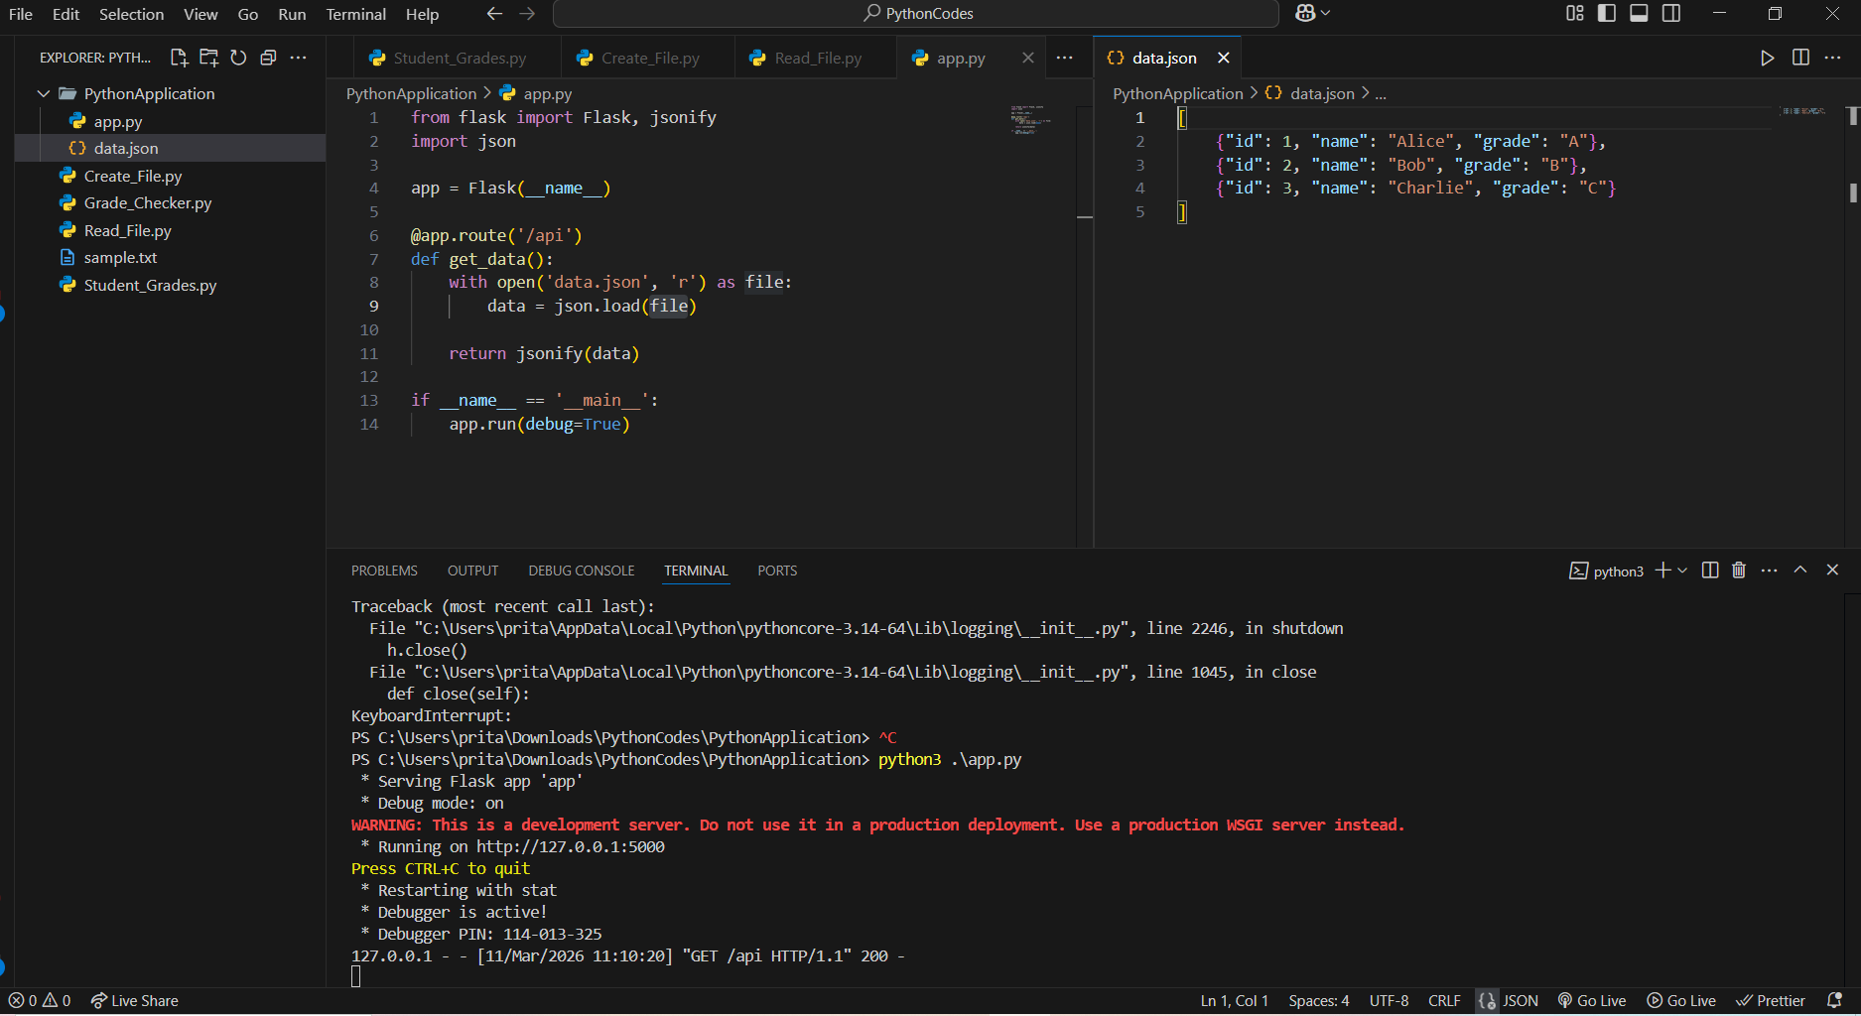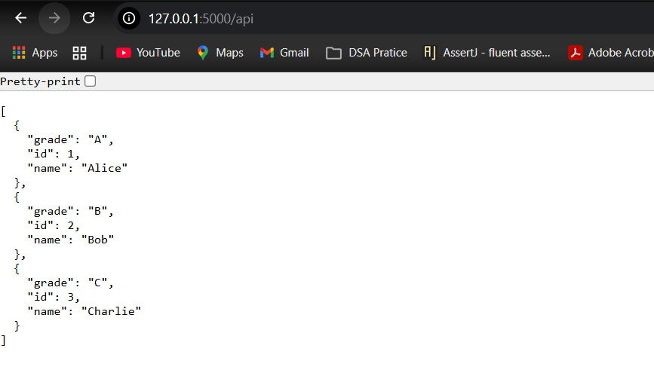
Explanation (for assignment)
- Flask is a lightweight Python web framework used to build APIs and web applications.
- The /api route is created using @app.route('/api').
- The program reads data from a backend file data.json using the json module.
- The jsonify() function converts the Python data into a JSON response.
- When the /api route is accessed, the server reads the data and sends it back to the client.
2. Create a form on the frontend that, when submitted, inserts data into MongoDB Atlas. Upon successful submission, the user should be redirected to another page displaying the message "Data submitted successfully". If there's an error during submission, display the error on the same page without redirection.
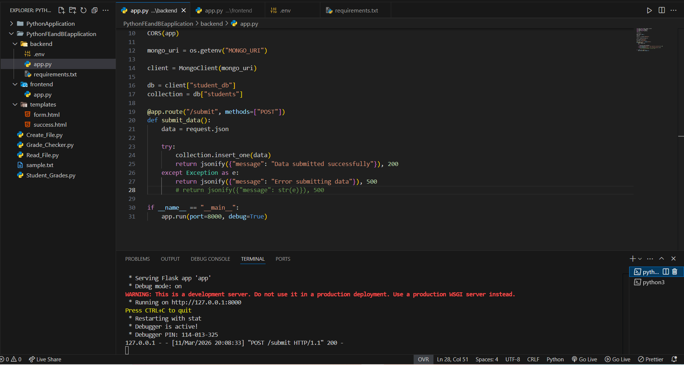 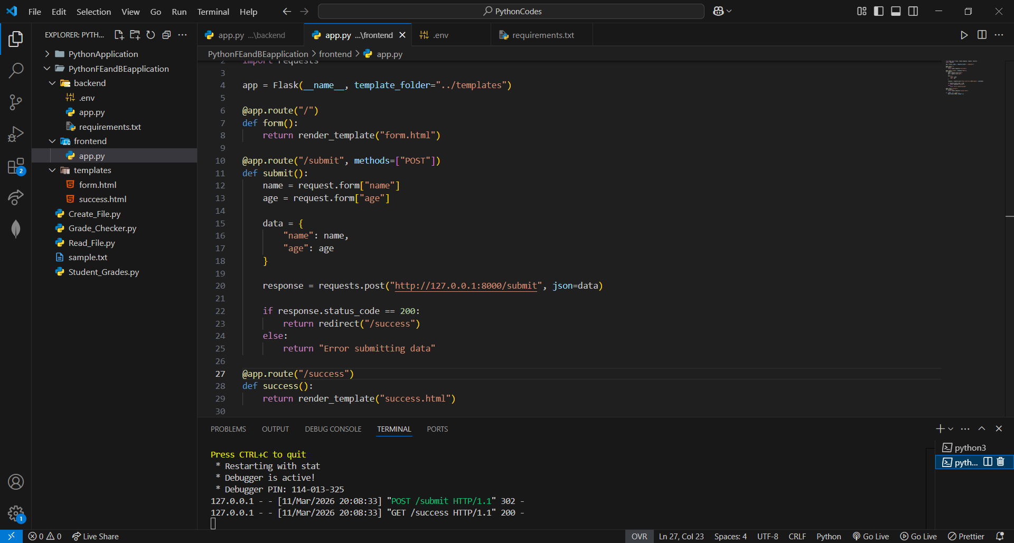 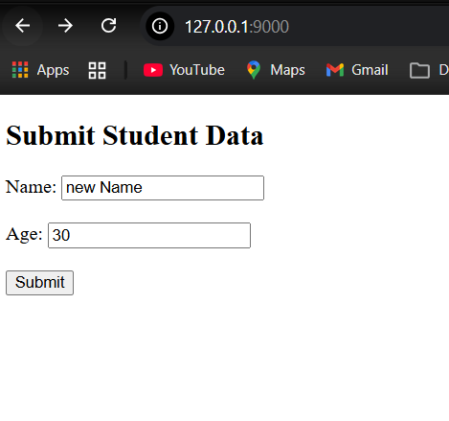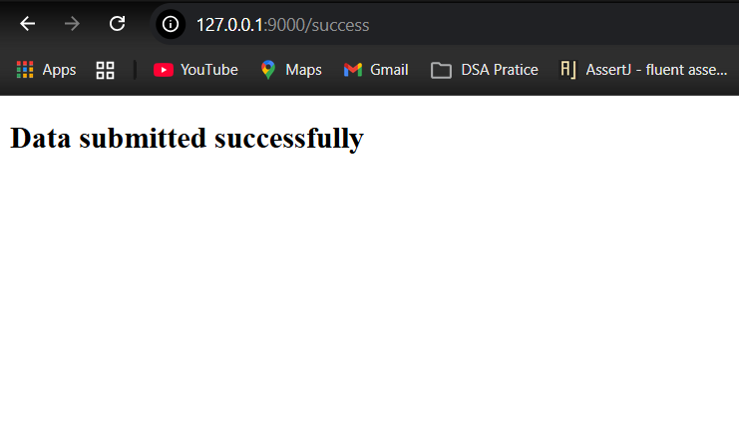Explanation (for assignment)
- The frontend Flask app provides the HTML form and handles user interaction.
- When the form is submitted, the frontend sends the data to the backend API using an HTTP POST request.
- The backend Flask app receives the data and stores it in MongoDB Atlas using the pymongo library.
- If the insertion is successful, the frontend redirects the user to a success page displaying the message "Data submitted successfully".
- If an error occurs, an error message is returned.

Submission Guidelines -: Attach Screenshots or command along with explanation and submit in doc(google doc or microsoft doc) format also attach github repo link

